**PRACTICAL – 1**

**Study and Installation of android studio**

**Android:**

* **Android** is a software package and linux based operating system for mobile devices such as tablet computers and smartphones.
* It is developed by Google and later the OHA (Open Handset Alliance). Java language is mainly used to write the android code even though other languages can be used.
* The goal of android project is to create a successful real-world product that improves the mobile experience for end users.
* There are many code names of android such as Lollipop, Kitkat, Jelly Bean, Ice cream Sandwich, Froyo, Ecliar, Donut etc which is covered in next page.

**Android Framework:**

Android is an open source, Linux-based software stack created for a wide array of devices and form factors. The following diagram shows the major components of the Android platform.

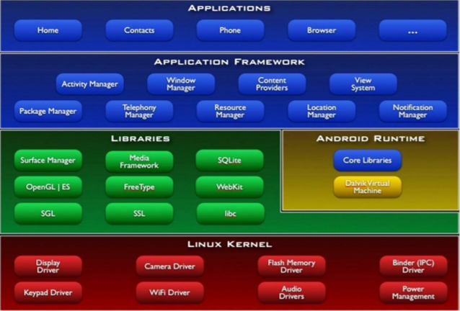

**Figure 1.** The Android software stack.

**Linux kernel**

At the bottom of the layers is Linux - Linux 3.6 with approximately 115 patches. This provides a level of abstraction between the device hardware and it contains all the essential hardware drivers like camera, keypad, display etc. Also, the kernel handles all the things that Linux is really good at such as networking and a vast array of device drivers, which take the pain out of interfacing to peripheral hardware.

**Libraries**

On top of Linux kernel there is a set of libraries including open-source Web browser engine WebKit, well known library libc, SQLite database which is a useful repository for storage and sharing of application data, libraries to play and record audio and video, SSL libraries responsible for Internet security etc.

**Android Libraries**

This category encompasses those Java-based libraries that are specific to Android development. Examples of libraries in this category include the application framework libraries in addition to those that facilitate user interface building, graphics drawing and database access. A summary of some key core Android libraries available to the Android developer is as follows-

* **android.app** − Provides access to the application model and is the cornerstone of all Android applications.
* **android.content** − Facilitates content access, publishing and messaging between applications and application components.
* **android.database** − Used to access data published by content providers and includes SQLite database management classes.
* **android.opengl** − A Java interface to the OpenGL ES 3D graphics rendering API.
* **android.os** − Provides applications with access to standard operating system services including messages, system services and inter-process communication.
* **android.text** − Used to render and manipulate text on a device display.
* **android.view** − The fundamental building blocks of application user interfaces.
* **android.widget** − A rich collection of pre-built user interface components such as buttons, labels, list views, layout managers, radio buttons etc.
* **android.webkit** − A set of classes intended to allow web-browsing capabilities to be built into applications.

Having covered the Java-based core libraries in the Android runtime, it is now time to turn our attention to the C/C++ based libraries contained in this layer of the Android software stack.

**Android Runtime**

This is the third section of the architecture and available on the second layer from the bottom. This section provides a key component called **Dalvik Virtual Machine** which is a kind of Java Virtual Machine specially designed and optimized for Android.

The Dalvik VM makes use of Linux core features like memory management and multi-threading, which is intrinsic in the Java language. The Dalvik VM enables every Android application to run in its own process, with its own instance of the Dalvik virtual machine.

The Android runtime also provides a set of core libraries which enable Android application developers to write Android applications using standard Java programming language.

**Application Framework**

The Application Framework layer provides many higher-level services to applications in the form of Java classes. Application developers are allowed to make use of these services in their applications.

The Android framework includes the following key services −

* **Activity Manager** − Controls all aspects of the application lifecycle and activity stack.
* **Content Providers** − Allows applications to publish and share data with other applications.
* **Resource Manager** − Provides access to non-code embedded resources such as strings, color settings and user interface layouts.
* **Notifications Manager** − Allows applications to display alerts and notifications to the user.
* **View System** − An extensible set of views used to create application user interfaces.

**Applications**

You will find all the Android application at the top layer. You will write your application to be installed on this layer only. Examples of such applications are Contacts Books, Browser, Games etc.

**Installation Of Android Studio :**

**Step 1**

To download the Android Studio, visit the official [Android Studio](https://developer.android.com/studio/) website in your web browser.

**Step 2**

Click on the "Download Android Studio" option.

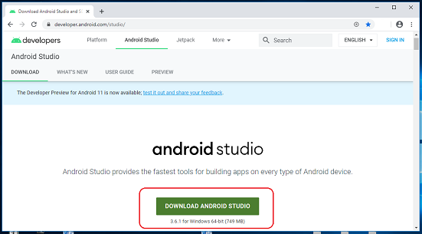

**Step 3**

Double click on the downloaded "Android Studio-ide.exe" file.

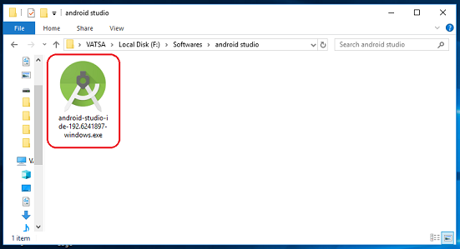

**Step 4**

"Android Studio Setup" will appear on the screen and click "Next" to proceed.

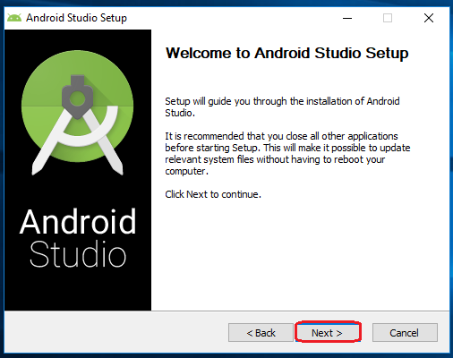

**Step 5**

Select the components that you want to install and click on the "Next" button.

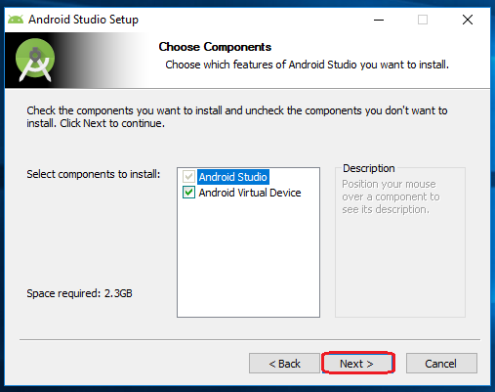

**Step 6**

Now, browse the location where you want to install the Android Studio and click "Next" to proceed.

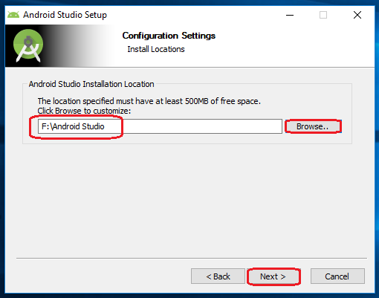

**Step 7**

Choose a start menu folder for the "Android Studio" shortcut and click the "Install" button to proceed.

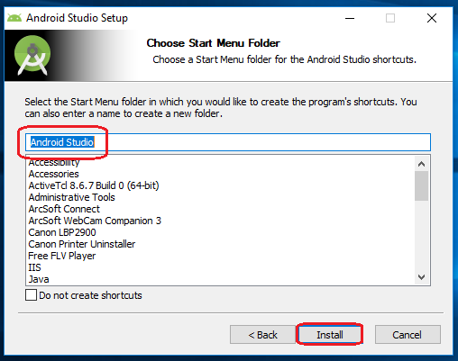

**Step 8**

After the successful completion of the installation, click on the "Next" button.

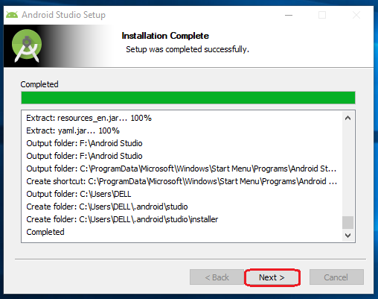

**Step 9**

Click on the "Finish" button to proceed.

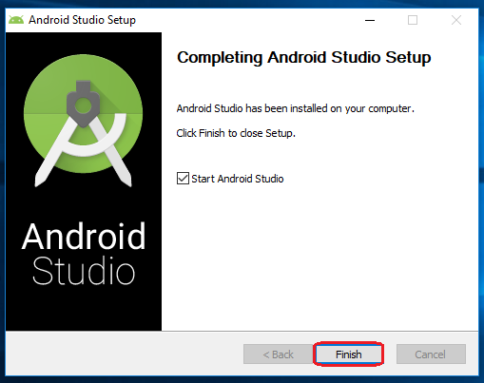

Now, your Android studio welcome screen will appear on the screen.

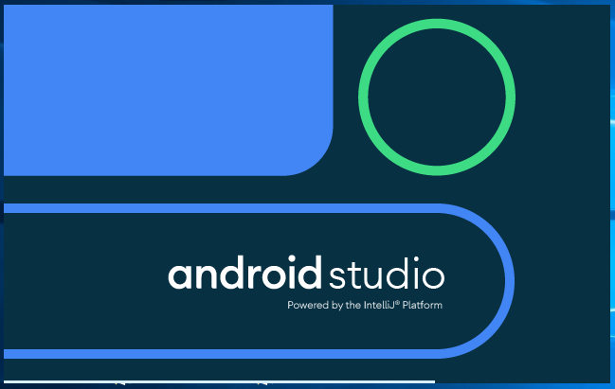

Android Studio Setup Configuration

**Step 10**

"Android Studio Setup Wizard" will appear on the screen with the welcome wizard. Click on the "Next" button.

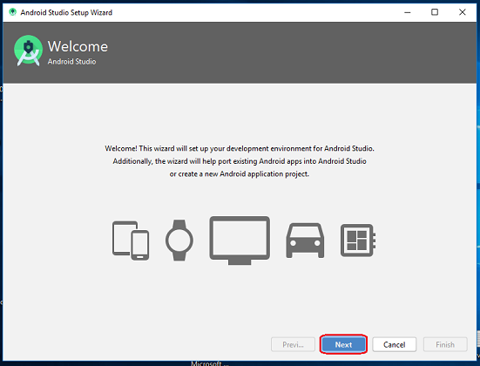

**Step 11**

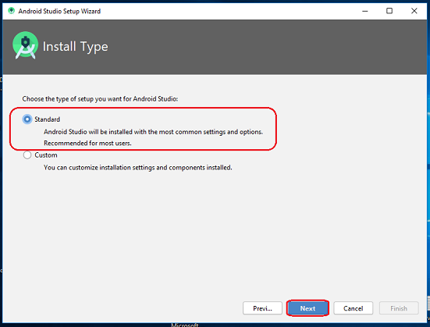Select (check) the "Standard" option if you are a beginner and do not have any idea about Android Studio. It will install the most common settings and options for you. Click "Next" to proceed.

**Step 12**

Now, select the user interface theme as you want. (I prefer Dark theme (Dracula) that is most liked by the coders). Then, click on the "Next" button.

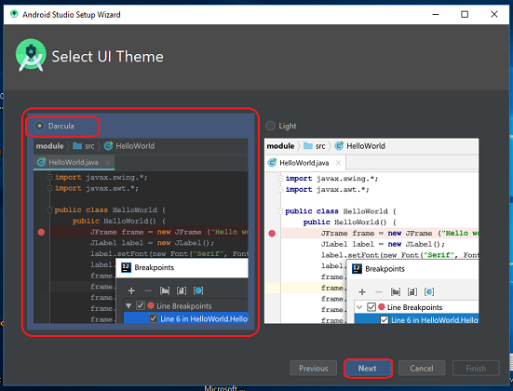

**Step 13**

Now, click on the "Finish" button to download all the SDK components.

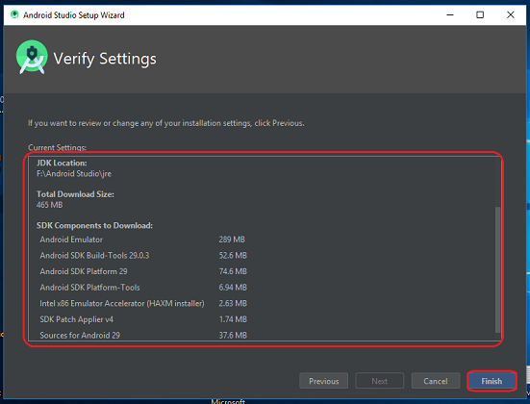

And, the downloading and installation process of components gets started.

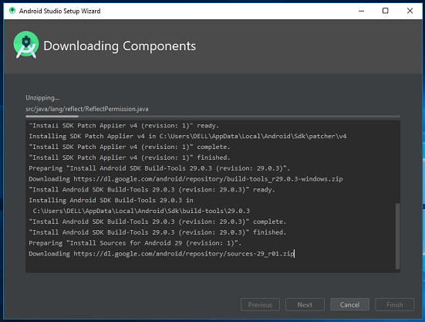

**Step 14**

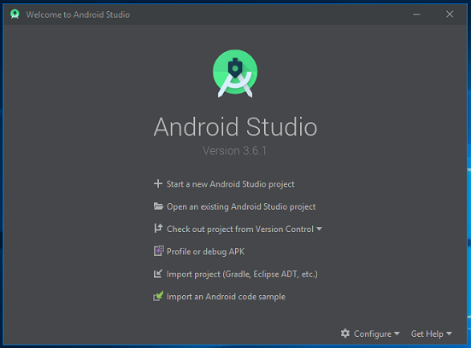After downloading all the necessary components, click on the "Finish" button.

Congrats, your Android Studio has been successfully installed in your system and you can start a new Android studio project.

**Hello World Practical**

**activity_main.xml**

<?xml version="1.0" encoding="utf-8"?>

<android.support.constraint.ConstraintLayout xmlns:android="http://schemas.android.com/apk/res/android"

xmlns:app="http://schemas.android.com/apk/res-auto"

xmlns:tools="http://schemas.android.com/tools"

android:layout_width="match_parent"

android:layout_height="match_parent"

android:minWidth="@android:dimen/app_icon_size"

app:barrierMargin="@android:dimen/notification_large_icon_width"

tools:context=".MainActivity">

<TextView

android:layout_width="wrap_content"

android:layout_height="wrap_content"

android:text="Hello Word"

app:layout_constraintBottom_toBottomOf="parent"

app:layout_constraintEnd_toEndOf="parent"

app:layout_constraintStart_toStartOf="parent"

app:layout_constraintTop_toTopOf="parent" />

</android.support.constraint.ConstraintLayout>

**MainActivity.java**

package com.example.lab_1_textview;

import android.support.v7.app.AppCompatActivity;

import android.os.Bundle;

public class MainActivity extends AppCompatActivity {

@Override

protected void onCreate(Bundle savedInstanceState) {

super.onCreate(savedInstanceState);

setContentView(R.layout.activity_main);

}

}

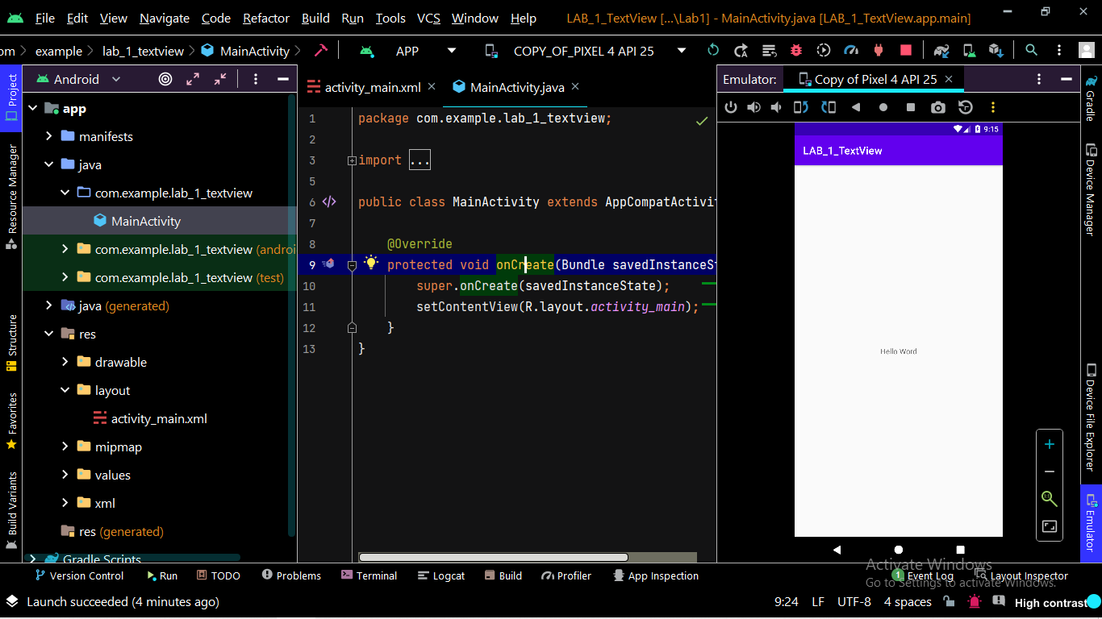**Output**

**PRACTICAL – 2**

**Create an android application to demonstrate the fundamental life cycle methods of android Activity. Using Log.d(), generate log messages.**

**MainActivty.java**

package com.example.lab_1_textview;

import android.support.v7.app.AppCompatActivity;

import android.os.Bundle;

import android.util.Log;

public class MainActivity extends AppCompatActivity {

String msg = "PrintLifeCycle";

/** Called when the activity is first created. */

@Override

public void onCreate(Bundle savedInstanceState) {

super.onCreate(savedInstanceState);

setContentView(R.layout.activity_main);

Log.d(msg, "The onCreate() event");

}

/** Called when the activity is about to become visible. */

@Override

protected void onStart() {

super.onStart();

Log.d(msg, "The onStart() event");

}

/** Called when the activity has become visible. */

@Override

protected void onResume() {

super.onResume();

Log.d(msg, "The onResume() event");

}

/** Called when another activity is taking focus. */

@Override

protected void onPause() {

super.onPause();

Log.d(msg, "The onPause() event");

}

/** Called when the activity is no longer visible. */

@Override

protected void onStop() {

super.onStop();

Log.d(msg, "The onStop() event");

}

/** Called just before the activity is destroyed. */

@Override

public void onDestroy() {

super.onDestroy();

Log.d(msg, "The onDestroy() event");

}

}

**LogCat File Output**

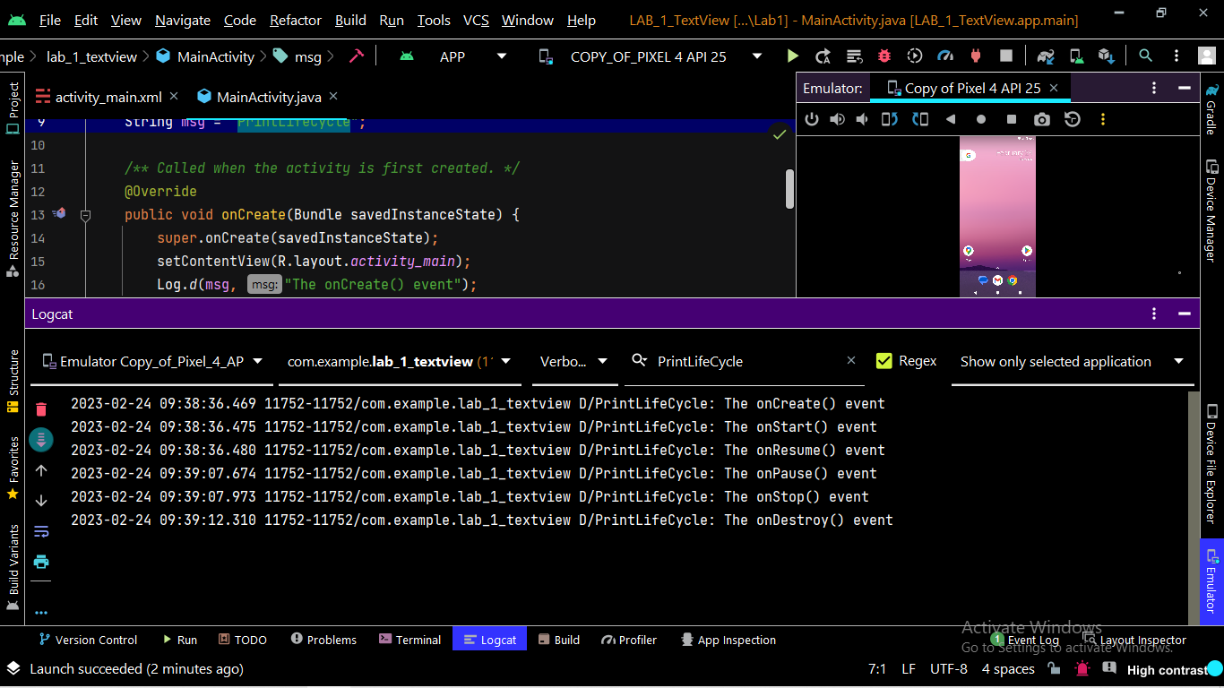

**Practical-3**

**Explicit and Implicit Intent**

**Activity_main.xml**

*<?*xml version="1.0" encoding="utf-8"*?>*<android.support.constraint.ConstraintLayout xmlns:android="http://schemas.android.com/apk/res/android"  
    xmlns:app="http://schemas.android.com/apk/res-auto"  
    xmlns:tools="http://schemas.android.com/tools"  
    android:layout_width="match_parent"  
    android:layout_height="match_parent"  
    tools:context=".MainActivity">  
  
    <TextView  
        android:layout_width="wrap_content"  
        android:layout_height="wrap_content"  
        android:text="Hello World!"  
        app:layout_constraintBottom_toBottomOf="parent"  
        app:layout_constraintEnd_toEndOf="parent"  
        app:layout_constraintStart_toStartOf="parent"  
        app:layout_constraintTop_toTopOf="parent" />  
  
    <Button  
        android:id="@+id/button"  
        android:layout_width="164dp"  
        android:layout_height="68dp"  
        android:text="@string/explicit"  
        android:textColor="#A5AEB3"  
        app:backgroundTint="#E91E63"  
        app:layout_constraintBottom_toBottomOf="parent"  
        app:layout_constraintEnd_toEndOf="parent"  
        app:layout_constraintHorizontal_bias="0.501"  
        app:layout_constraintStart_toStartOf="parent"  
        app:layout_constraintTop_toTopOf="parent"  
        app:layout_constraintVertical_bias="0.316" />  
  
    <Button  
        android:id="@+id/button2"  
        android:layout_width="190dp"  
        android:layout_height="81dp"  
        android:text="@string/implicit"  
        android:textColor="#455A64"  
        app:backgroundTint="#FFC107"  
        app:layout_constraintBottom_toBottomOf="parent"  
        app:layout_constraintEnd_toEndOf="parent"  
        app:layout_constraintStart_toStartOf="parent"  
        app:layout_constraintTop_toBottomOf="@+id/button" />  
  
  
</android.support.constraint.ConstraintLayout>

**MainActivity.java**

package com.example.intent_final;  
  
import android.support.v7.app.AppCompatActivity;  
import android.os.Bundle;  
import android.content.Intent;  
  
  
import android.net.Uri;  
  
import android.widget.Button;  
  
public class MainActivity extends AppCompatActivity {  
  
    @Override  
    protected void onCreate(Bundle savedInstanceState) {  
        super.onCreate(savedInstanceState);  
        setContentView(R.layout.*activity_main*);  
        Button b1 = findViewById(R.id.*button*);  
        Button b2 = findViewById(R.id.*button2*);  
        b1.setOnClickListener(v -> {  
            Intent i=new Intent(MainActivity.this,SecondActivity.class);  
            startActivity(i);  
        });  
        b2.setOnClickListener(v -> {  
            Intent go=new Intent(Intent.*ACTION_VIEW*);  
            go.setData(Uri.*parse*("https://www.vvpedulink.ac.in/"));  
            startActivity(go);  
        });  
    }  
}

**second_layout.xml**

*<?*xml version="1.0" encoding="utf-8"*?>*<android.support.constraint.ConstraintLayout xmlns:android="http://schemas.android.com/apk/res/android"  
    xmlns:app="http://schemas.android.com/apk/res-auto"  
    xmlns:tools="http://schemas.android.com/tools"  
    android:layout_width="match_parent"  
    android:layout_height="match_parent"  
    tools:context=".SecondActivity">  
  
<TextView  
        android:id="@+id/textView"  
        android:layout_width="wrap_content"  
        android:layout_height="wrap_content"  
        android:text="@string/welcome_to_v_v_p_engineering_college"  
        android:textSize="20sp"  
        app:layout_constraintBottom_toBottomOf="parent"  
        app:layout_constraintEnd_toEndOf="parent"  
        app:layout_constraintStart_toStartOf="parent"  
        app:layout_constraintTop_toTopOf="parent" />  
</android.support.constraint.ConstraintLayout>

**SecondActivity.java**

package com.example.intent_final;  
  
import android.support.v7.app.AppCompatActivity;  
import android.graphics.Color;  
import android.os.Bundle;  
import android.widget.TextView;  
import android.widget.Toast;  
  
  
public class SecondActivity extends AppCompatActivity{  
  
    protected void onCreate(Bundle savedInstanceState) {  
        super.onCreate(savedInstanceState);  
        setContentView(R.layout.*second_layout*);  
        TextView data = findViewById(R.id.*textView*);  
        data.setTextColor(Color.*RED*);  
        Toast.*makeText*(getApplicationContext(),"Welcome to Second Activity",Toast.*LENGTH_LONG*).show();  
    }  
}

**AndroidManifest.xml**

*<?*xml version="1.0" encoding="utf-8"*?>*<manifest xmlns:android="http://schemas.android.com/apk/res/android"  
    xmlns:tools="http://schemas.android.com/tools">  
  
    <application  
        android:allowBackup="true"  
        android:dataExtractionRules="@xml/data_extraction_rules"  
        android:fullBackupContent="@xml/backup_rules"  
        android:icon="@mipmap/ic_launcher"  
        android:label="@string/app_name"  
        android:supportsRtl="true"  
        android:theme="@style/Theme.Intentfinal"  
        tools:targetApi="31">  
        <activity  
            android:name=".MainActivity"  
            android:exported="true">  
            <intent-filter>  
               <action android:name="android.intent.action.MAIN" />  
  
               <category android:name="android.intent.category.LAUNCHER" />  
            </intent-filter>  
        </activity>  
  
        <activity android:name=".SecondActivity">  
        </activity>  
    </application>  
  
</manifest>

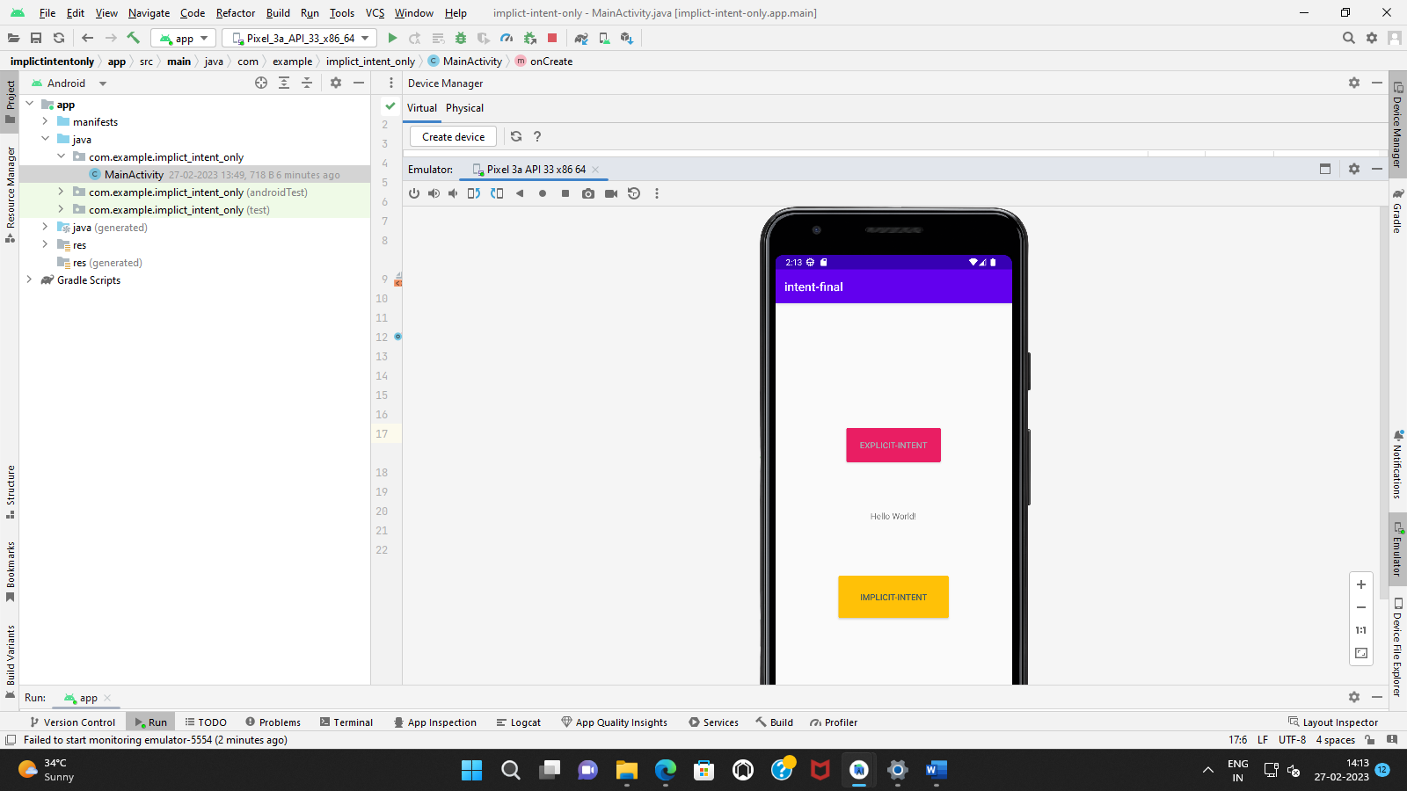

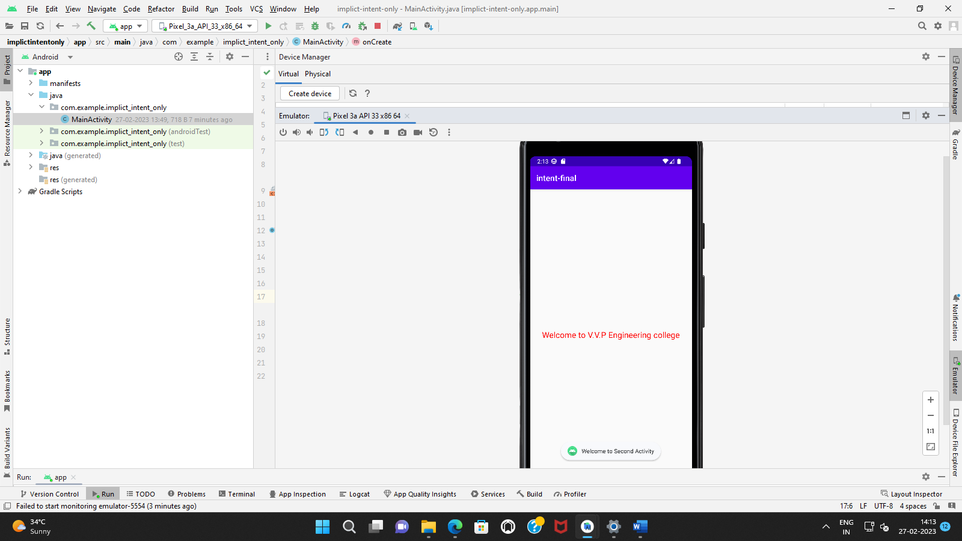

**Practical-4**

**Fragments in android**

**activity_main.xml**

*<?*xml version="1.0" encoding="utf-8"*?>*<LinearLayout xmlns:android="http://schemas.android.com/apk/res/android"  
 xmlns:app="http://schemas.android.com/apk/res-auto"  
 xmlns:tools="http://schemas.android.com/tools"  
 android:layout_width="fill_parent"  
 android:layout_height="fill_parent"  
 tools:context=".MainActivity">  
  
 <fragment  
 android:id="@+id/fragment1"  
 android:name="com.example.fragment_p4.Fragment1"  
 android:layout_width="match_parent"  
 android:layout_height="match_parent"  
 android:layout_weight="1"  
 />  
  
 <fragment  
 android:id="@+id/fragment2"  
 android:name="com.example.fragment_p4.Fragment2"  
 android:layout_width="match_parent"  
 android:layout_height="match_parent"  
 android:layout_weight="1"  
 />  
  
</LinearLayout>

**fragment1.xml**

<FrameLayout xmlns:android="http://schemas.android.com/apk/res/android"  
 xmlns:tools="http://schemas.android.com/tools"  
 android:layout_width="match_parent"  
 android:layout_height="match_parent"  
 android:background="#FFCA28"  
 tools:context=".Fragment1">  
  
 *<!-- TODO: Update blank fragment layout -->* <TextView  
 android:layout_width="match_parent"  
 android:layout_height="match_parent"  
 android:text="hello Fragmant One" />  
  
</FrameLayout>

**fragment_2.xml**

*<?*xml version="1.0" encoding="utf-8"*?>*<FrameLayout xmlns:android="http://schemas.android.com/apk/res/android"  
 xmlns:tools="http://schemas.android.com/tools"  
 android:layout_width="match_parent"  
 android:layout_height="match_parent"  
 android:background="@color/teal_200"  
 tools:context=".Fragment2">  
  
 *<!-- TODO: Update blank fragment layout -->* <TextView  
 android:layout_width="match_parent"  
 android:layout_height="match_parent"  
 android:text="hello" />  
  
</FrameLayout>

**MainActivity.class**

package com.example.fragment_p4;  
  
import androidx.appcompat.app.AppCompatActivity;  
  
import android.os.Bundle;  
  
public class MainActivity extends AppCompatActivity {  
  
 @Override  
 protected void onCreate(Bundle savedInstanceState) {  
 super.onCreate(savedInstanceState);  
 setContentView(R.layout.*activity_main*);  
 }  
}

**Fragment1.java**

package com.example.fragment_p4;  
  
import android.os.Bundle;  
  
import androidx.fragment.app.Fragment;  
  
import android.view.LayoutInflater;  
import android.view.View;  
import android.view.ViewGroup;  
  
public class Fragment1 extends Fragment {  
  
  
 @Override  
 public void onCreate(Bundle savedInstanceState) {  
 super.onCreate(savedInstanceState);  
  
 }  
  
 @Override  
 public View onCreateView(LayoutInflater inflater, ViewGroup container,  
 Bundle savedInstanceState) {  
 *// Inflate the layout for this fragment* return inflater.inflate(R.layout.*fragment1*, container, false);  
 }  
}

**Fragment2.java**

package com.example.fragment_p4;  
  
import android.os.Bundle;  
  
import androidx.fragment.app.Fragment;  
  
import android.view.LayoutInflater;  
import android.view.View;  
import android.view.ViewGroup;  
  
  
public class Fragment2 extends Fragment {  
  
  
 public Fragment2() {  
 *// Required empty public constructor* }  
  
  
  
 @Override  
 public void onCreate(Bundle savedInstanceState) {  
 super.onCreate(savedInstanceState);  
  
 }  
  
 @Override  
 public View onCreateView(LayoutInflater inflater, ViewGroup container,  
 Bundle savedInstanceState) {  
 *// Inflate the layout for this fragment* return inflater.inflate(R.layout.*fragment_2*, container, false);  
 }  
}

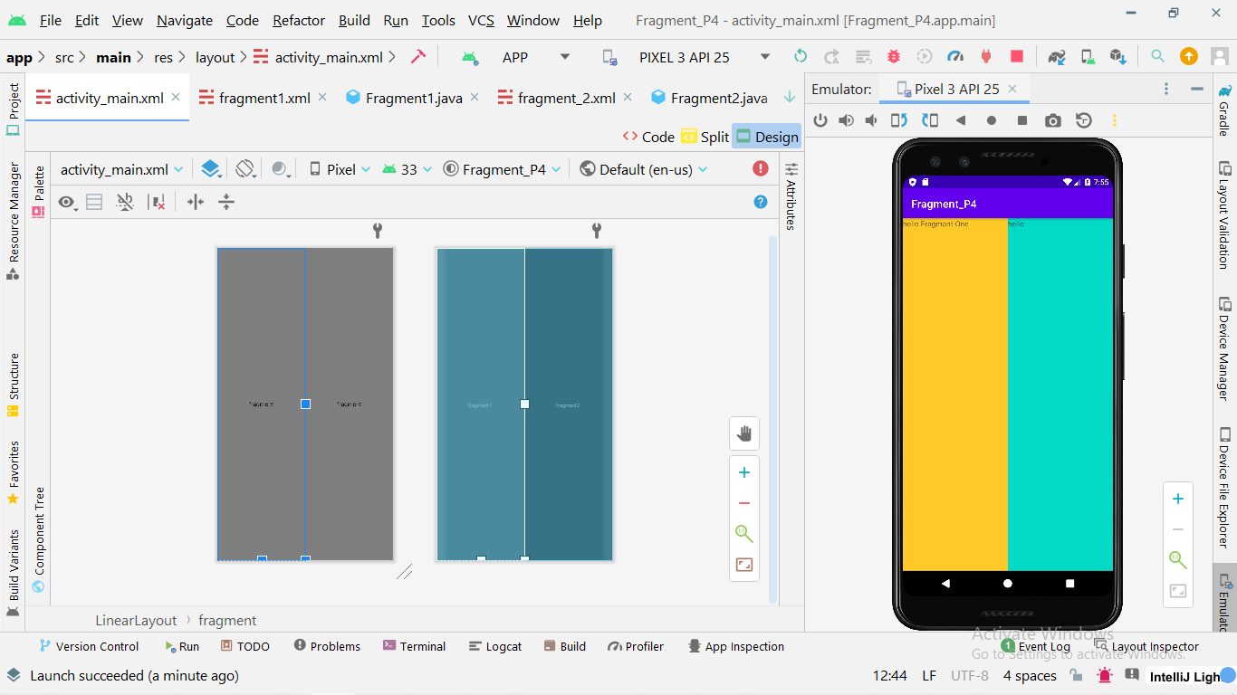

**Practical-5**

**TextView / EditText and Buttons in android**

**MainActivity.java**

package com.example.meterintoinche;  
  
import androidx.appcompat.app.AppCompatActivity;  
  
import android.os.Bundle;  
import android.view.View;  
import android.widget.Button;  
import android.widget.EditText;  
import android.widget.TextView;  
  
public class MainActivity extends AppCompatActivity {  
  
 TextView tvResult;  
 EditText etName , etPassword;  
 Button btnShow;  
  
 @Override  
 protected void onCreate(Bundle savedInstanceState) {  
 super.onCreate(savedInstanceState);  
 setContentView(R.layout.*activity_main*);  
  
 *//init view* init();  
 }  
  
 private void init(){  
 tvResult = findViewById(R.id.*tvResult*);  
 etName = findViewById(R.id.*etName*);  
 etPassword = findViewById(R.id.*etPassword*);  
 btnShow = findViewById(R.id.*btnShow*);  
 }  
  
 public void showResult(View view){  
  
 String name = etName.getText().toString();  
 String password = etPassword.getText().toString();  
  
 tvResult.setText("Your Name is : "+name+"\nYour Password is : "+password);  
 }  
}

**activity_main.xml**

*<?*xml version="1.0" encoding="utf-8"*?>*<androidx.constraintlayout.widget.ConstraintLayout xmlns:android="http://schemas.android.com/apk/res/android"  
 xmlns:app="http://schemas.android.com/apk/res-auto"  
 xmlns:tools="http://schemas.android.com/tools"  
 android:layout_width="match_parent"  
 android:layout_height="match_parent"  
 tools:context=".MainActivity">  
  
  
 <TextView  
 android:id="@+id/tvName"  
 android:layout_width="wrap_content"  
 android:layout_height="wrap_content"  
 android:text="Enter Name"  
 android:textStyle="bold"  
 app:layout_constraintBottom_toBottomOf="parent"  
 app:layout_constraintEnd_toEndOf="parent"  
 app:layout_constraintHorizontal_bias="0.48"  
 app:layout_constraintStart_toStartOf="parent"  
 app:layout_constraintTop_toTopOf="parent"  
 app:layout_constraintVertical_bias="0.101" />  
  
 <EditText  
 android:id="@+id/etName"  
 android:layout_width="wrap_content"  
 android:layout_height="wrap_content"  
 android:layout_marginEnd="100dp"  
 android:ems="10"  
 android:inputType="text"  
 android:hint="Name "  
 app:layout_constraintBottom_toBottomOf="parent"  
 app:layout_constraintEnd_toEndOf="parent"  
 app:layout_constraintTop_toTopOf="parent"  
 app:layout_constraintVertical_bias="0.182" />  
  
  
 <TextView  
 android:id="@+id/tvPassword"  
 android:layout_width="wrap_content"  
 android:layout_height="wrap_content"  
 android:text="Enter Password"  
 android:textStyle="bold"  
 app:layout_constraintBottom_toBottomOf="parent"  
 app:layout_constraintEnd_toEndOf="parent"  
 app:layout_constraintHorizontal_bias="0.501"  
 app:layout_constraintStart_toStartOf="parent"  
 app:layout_constraintTop_toTopOf="parent"  
 app:layout_constraintVertical_bias="0.29" />  
  
 <EditText  
 android:id="@+id/etPassword"  
 android:layout_width="wrap_content"  
 android:layout_height="wrap_content"  
 android:layout_marginEnd="96dp"  
 android:ems="10"  
 android:hint="Password "  
 android:inputType="textPassword"  
 app:layout_constraintBottom_toBottomOf="parent"  
 app:layout_constraintEnd_toEndOf="parent"  
 app:layout_constraintTop_toTopOf="parent"  
 app:layout_constraintVertical_bias="0.374" />  
  
 <Button  
 android:id="@+id/btnShow"  
 android:layout_width="wrap_content"  
 android:layout_height="wrap_content"  
 android:onClick="showResult"  
 android:text="Show"  
 app:layout_constraintBottom_toBottomOf="parent"  
 app:layout_constraintEnd_toEndOf="parent"  
 app:layout_constraintStart_toStartOf="parent"  
 app:layout_constraintTop_toTopOf="parent" />  
  
 <TextView  
 android:id="@+id/tvResult"  
 android:layout_width="wrap_content"  
 android:layout_height="wrap_content"  
 android:background="#FFEB3B"  
 android:textColor="#3D5AFE"  
 android:textSize="24dp"  
 app:layout_constraintBottom_toBottomOf="parent"  
 app:layout_constraintEnd_toEndOf="parent"  
 app:layout_constraintStart_toStartOf="parent"  
 app:layout_constraintTop_toTopOf="parent"  
 app:layout_constraintVertical_bias="0.675" />  
  
  
</androidx.constraintlayout.widget.ConstraintLayout>

**Output:**

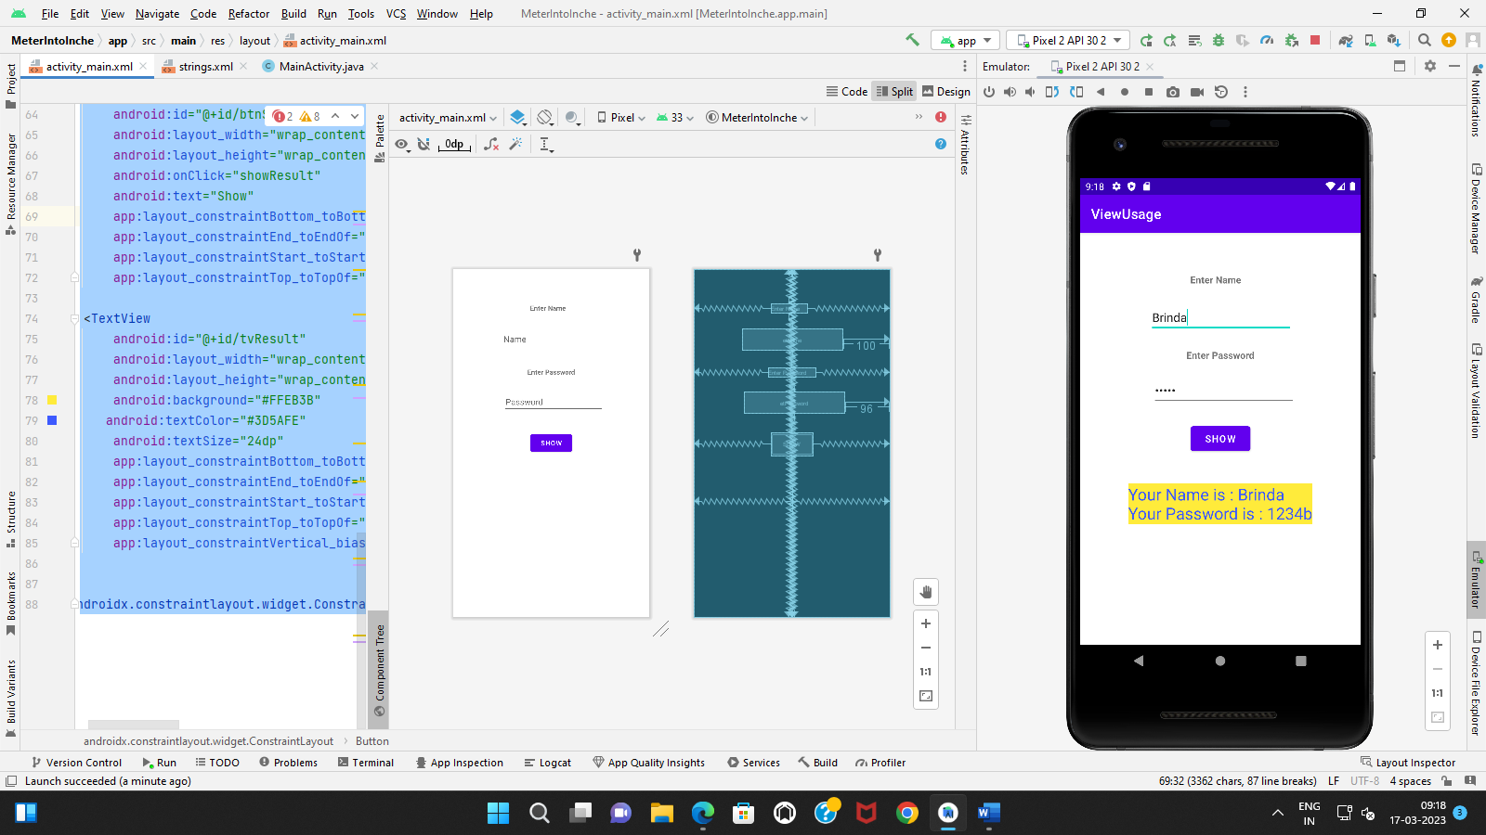

**Practical-6**

**convert Meters to Inches.**

**MainActivity.java**

package com.example.meterintoinche;  
  
import androidx.appcompat.app.AppCompatActivity;  
  
import android.os.Bundle;  
import android.view.View;  
import android.widget.Button;  
import android.widget.EditText;  
import android.widget.TextView;  
  
public class MainActivity extends AppCompatActivity {  
  
 TextView tvResult;  
 EditText etMeters;  
 Button btnMtoI;  
  
 @Override  
 protected void onCreate(Bundle savedInstanceState) {  
 super.onCreate(savedInstanceState);  
 setContentView(R.layout.*activity_main*);  
  
 *//init view* init();  
 }  
  
 private void init(){  
 tvResult = findViewById(R.id.*tvResult*);  
 etMeters = findViewById(R.id.*etMeters*);  
 btnMtoI = findViewById(R.id.*btnMtoI*);  
 }  
  
 public void showResult(View view){  
 Double meter = Double.*parseDouble*(etMeters.getText().toString());  
  
 Double result = meter*39.3700787;  
  
 tvResult.setText(result.toString());  
 }  
}

**activity_main.xml**

*<?*xml version="1.0" encoding="utf-8"*?>*<androidx.constraintlayout.widget.ConstraintLayout xmlns:android="http://schemas.android.com/apk/res/android"  
 xmlns:app="http://schemas.android.com/apk/res-auto"  
 xmlns:tools="http://schemas.android.com/tools"  
 android:layout_width="match_parent"  
 android:layout_height="match_parent"  
 tools:context=".MainActivity">  
  
  
 <TextView  
 android:id="@+id/textView"  
 android:layout_width="wrap_content"  
 android:layout_height="wrap_content"  
 android:text="Enter A length in Meters"  
 app:layout_constraintBottom_toBottomOf="parent"  
 app:layout_constraintEnd_toEndOf="parent"  
 app:layout_constraintStart_toStartOf="parent"  
 app:layout_constraintTop_toTopOf="parent"  
 app:layout_constraintVertical_bias="0.112" />  
  
  
 <EditText  
 android:id="@+id/etMeters"  
 android:layout_width="wrap_content"  
 android:layout_height="wrap_content"  
 android:layout_marginEnd="100dp"  
 android:ems="10"  
 android:inputType="number"  
 android:text="Name"  
 app:layout_constraintBottom_toBottomOf="parent"  
 app:layout_constraintEnd_toEndOf="parent"  
 app:layout_constraintTop_toTopOf="parent"  
 app:layout_constraintVertical_bias="0.182" />  
  
 <TextView  
 android:id="@+id/tvResult"  
 android:layout_width="wrap_content"  
 android:layout_height="wrap_content"  
 android:gravity="center_horizontal"  
 android:text="Result In Inches"  
 app:layout_constraintBottom_toBottomOf="parent"  
 app:layout_constraintEnd_toEndOf="parent"  
 app:layout_constraintStart_toStartOf="parent"  
 app:layout_constraintTop_toTopOf="parent"  
 app:layout_constraintVertical_bias="0.325" />  
  
 <Button  
 android:id="@+id/btnMtoI"  
 android:layout_width="wrap_content"  
 android:layout_height="wrap_content"  
 android:onClick="showResult"  
 android:text="Meter to Inches"  
 app:layout_constraintBottom_toBottomOf="parent"  
 app:layout_constraintEnd_toEndOf="parent"  
 app:layout_constraintStart_toStartOf="parent"  
 app:layout_constraintTop_toTopOf="parent" />  
  
  
</androidx.constraintlayout.widget.ConstraintLayout>

**Output:**

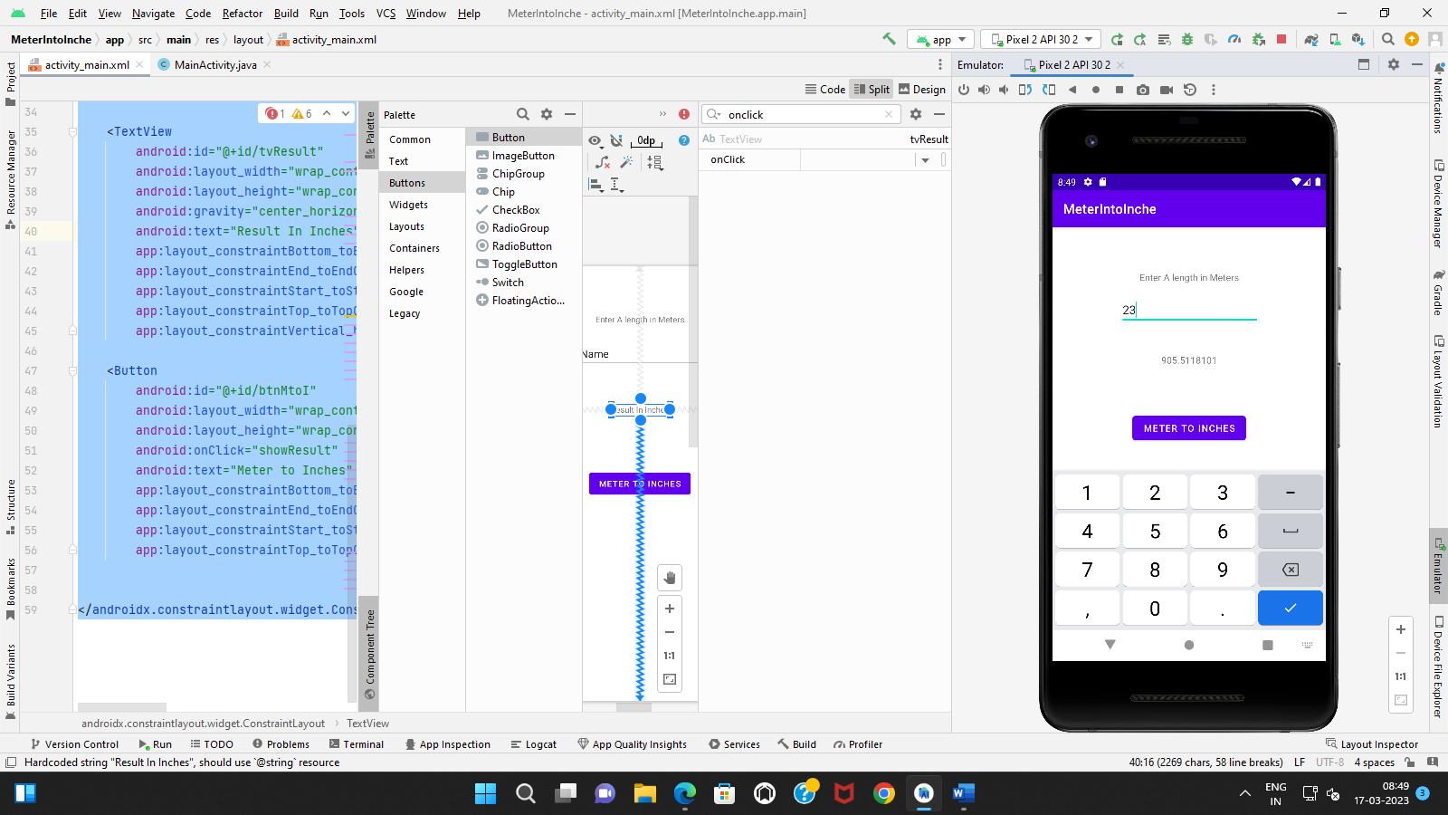

**Practical-7**

**convert USD to INR.**

**MainActivity.java**

package com.example.meterintoinche;  
  
import androidx.appcompat.app.AppCompatActivity;  
  
import android.os.Bundle;  
import android.view.View;  
import android.widget.Button;  
import android.widget.EditText;  
import android.widget.TextView;  
  
public class MainActivity extends AppCompatActivity {  
  
 TextView tvResult;  
 EditText etUSD;  
 Button btnUSDtoINR;  
  
 @Override  
 protected void onCreate(Bundle savedInstanceState) {  
 super.onCreate(savedInstanceState);  
 setContentView(R.layout.*activity_main*);  
  
 *//init view* init();  
 }  
  
 private void init(){  
 tvResult = findViewById(R.id.*tvResult*);  
 etUSD = findViewById(R.id.*etUSD*);  
 btnUSDtoINR = findViewById(R.id.*btnUSDtoINR*);  
 }  
  
 public void showResult(View view){  
 Double USD = Double.*parseDouble*(etUSD.getText().toString());  
  
 Double result = USD*82.47;  
  
 tvResult.setText(result.toString());  
 }  
}

**activity_main.xml**

*<?*xml version="1.0" encoding="utf-8"*?>*<androidx.constraintlayout.widget.ConstraintLayout xmlns:android="http://schemas.android.com/apk/res/android"  
 xmlns:app="http://schemas.android.com/apk/res-auto"  
 xmlns:tools="http://schemas.android.com/tools"  
 android:layout_width="match_parent"  
 android:layout_height="match_parent"  
 tools:context=".MainActivity">  
  
  
 <TextView  
 android:id="@+id/textView"  
 android:layout_width="wrap_content"  
 android:layout_height="wrap_content"  
 android:text="Enter USD"  
 app:layout_constraintBottom_toBottomOf="parent"  
 app:layout_constraintEnd_toEndOf="parent"  
 app:layout_constraintStart_toStartOf="parent"  
 app:layout_constraintTop_toTopOf="parent"  
 app:layout_constraintVertical_bias="0.112" />  
  
  
 <EditText  
 android:id="@+id/etUSD"  
 android:layout_width="wrap_content"  
 android:layout_height="wrap_content"  
 android:layout_marginEnd="100dp"  
 android:ems="10"  
 android:inputType="number"  
 android:hint="USD Here"  
 app:layout_constraintBottom_toBottomOf="parent"  
 app:layout_constraintEnd_toEndOf="parent"  
 app:layout_constraintTop_toTopOf="parent"  
 app:layout_constraintVertical_bias="0.182" />  
  
 <TextView  
 android:id="@+id/tvResult"  
 android:layout_width="wrap_content"  
 android:layout_height="wrap_content"  
 android:gravity="center_horizontal"  
 android:text="Result In USD TO INR"  
 app:layout_constraintBottom_toBottomOf="parent"  
 app:layout_constraintEnd_toEndOf="parent"  
 app:layout_constraintStart_toStartOf="parent"  
 app:layout_constraintTop_toTopOf="parent"  
 app:layout_constraintVertical_bias="0.325" />  
  
 <Button  
 android:id="@+id/btnUSDtoINR"  
 android:layout_width="wrap_content"  
 android:layout_height="wrap_content"  
 android:onClick="showResult"  
 android:text="Meter to Inches"  
 app:layout_constraintBottom_toBottomOf="parent"  
 app:layout_constraintEnd_toEndOf="parent"  
 app:layout_constraintStart_toStartOf="parent"  
 app:layout_constraintTop_toTopOf="parent" />  
  
  
</androidx.constraintlayout.widget.ConstraintLayout>

**Output:**

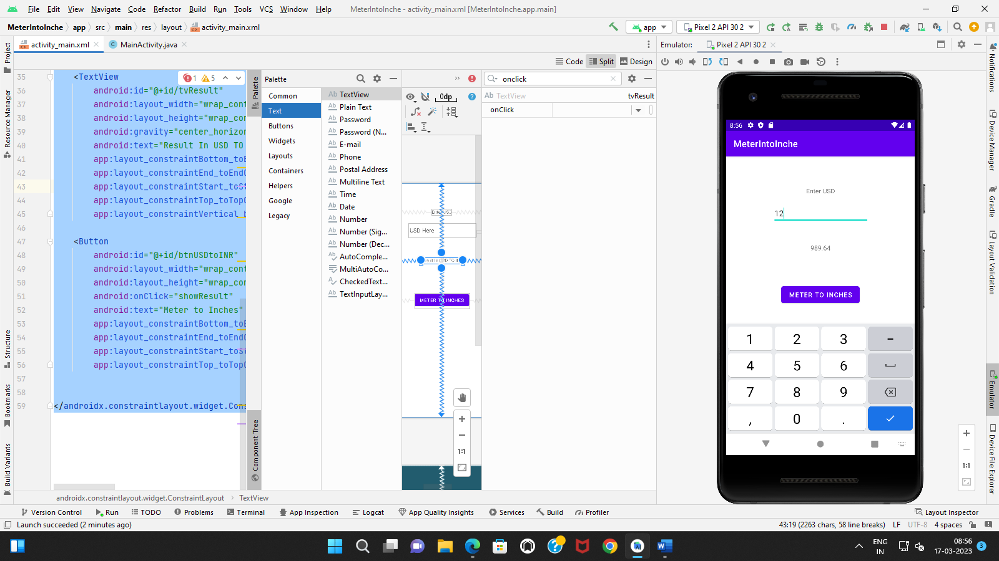

**Practical-8**

**simple calculator**

**MainActivity.java**

package com.example.addition;  
  
import androidx.appcompat.app.AppCompatActivity;  
  
import android.os.Bundle;  
import android.view.View;  
import android.widget.EditText;  
import android.widget.TextView;  
import android.widget.Toast;  
  
public class MainActivity extends AppCompatActivity {  
  
  
 @Override  
 protected void onCreate(Bundle savedInstanceState) {  
 super.onCreate(savedInstanceState);  
 setContentView(R.layout.*activity_main*);  
  
  
 }  
  
 public void sum(View v) {  
 EditText etA = (EditText) findViewById(R.id.*txtA*);  
 EditText etB = (EditText) findViewById(R.id.*txtB*);  
 EditText etC = (EditText) findViewById(R.id.*txtC*);  
 Double a, b, c;  
  
 if (etA.getText().toString().length() == 0) {  
 Toast.*makeText*(this, "Please Enter First Value", Toast.*LENGTH_LONG*).show();  
 } else if (etB.getText().toString().length() == 0) {  
 Toast.*makeText*(this, "Please Enter Second Value", Toast.*LENGTH_LONG*).show();  
 } else {  
 a = Double.*parseDouble*(etA.getText().toString());  
 b = Double.*parseDouble*(etB.getText().toString());  
 c = a + b;  
  
 etC.setText(c.toString());  
  
 }  
 }  
  
 public void sub(View v1) {  
 EditText etA1 = (EditText) findViewById(R.id.*txtA*);  
 EditText etB1 = (EditText) findViewById(R.id.*txtB*);  
 EditText etC1 = (EditText) findViewById(R.id.*txtC*);  
 Float a, b, c;  
  
 a = Float.*parseFloat*(etA1.getText().toString());  
 b = Float.*parseFloat*(etB1.getText().toString());  
 c = Math.*abs*(a - b);  
  
 etC1.setText(c.toString());  
}  
 public void mult(View v2)  
 {  
 EditText etA2 = (EditText) findViewById(R.id.*txtA*);  
 EditText etB2 = (EditText) findViewById(R.id.*txtB*);  
 EditText etC2 = (EditText) findViewById(R.id.*txtC*);  
 Double a, b, c;  
  
 a = Double.*parseDouble*(etA2.getText().toString());  
 b = Double.*parseDouble*(etB2.getText().toString());  
 c = a * b;  
  
 etC2.setText(c.toString());  
 }  
  
 public void div(View v2)  
 {  
 EditText etA2 = (EditText) findViewById(R.id.*txtA*);  
 EditText etB2 = (EditText) findViewById(R.id.*txtB*);  
 EditText etC2 = (EditText) findViewById(R.id.*txtC*);  
 Double a, b, c;  
  
 a = Double.*parseDouble*(etA2.getText().toString());  
 b = Double.*parseDouble*(etB2.getText().toString());  
 c = a / b;  
  
 etC2.setText(c.toString());  
  
}  
  
 public void clear(View v3)  
 {  
 EditText etA3 = (EditText) findViewById(R.id.*txtA*);  
 EditText etB3 = (EditText) findViewById(R.id.*txtB*);  
 EditText etC3 = (EditText) findViewById(R.id.*txtC*);  
  
 etA3.setText("");  
 etB3.setText("");  
 etC3.setText("");  
 }  
  
}  
  
**activity_main.xml**

*<?*xml version="1.0" encoding="utf-8"*?>*<androidx.constraintlayout.widget.ConstraintLayout xmlns:android="http://schemas.android.com/apk/res/android"  
 xmlns:app="http://schemas.android.com/apk/res-auto"  
 xmlns:tools="http://schemas.android.com/tools"  
 android:id="@+id/page"  
 android:layout_width="match_parent"  
 android:layout_height="match_parent"  
 tools:context=".MainActivity">  
  
 <TextView  
 android:id="@+id/textView"  
 android:layout_width="wrap_content"  
 android:layout_height="wrap_content"  
 android:text="Enter First No. : "  
 app:layout_constraintBottom_toBottomOf="parent"  
 app:layout_constraintEnd_toEndOf="parent"  
 app:layout_constraintHorizontal_bias="0.051"  
 app:layout_constraintStart_toStartOf="parent"  
 app:layout_constraintTop_toTopOf="parent"  
 app:layout_constraintVertical_bias="0.077" />  
  
 <TextView  
 android:id="@+id/textView2"  
 android:layout_width="wrap_content"  
 android:layout_height="wrap_content"  
 android:text="Enter Second No.: "  
 app:layout_constraintBottom_toBottomOf="parent"  
 app:layout_constraintEnd_toEndOf="parent"  
 app:layout_constraintHorizontal_bias="0.045"  
 app:layout_constraintStart_toStartOf="parent"  
 app:layout_constraintTop_toTopOf="parent"  
 app:layout_constraintVertical_bias="0.209" />  
  
 <EditText  
 android:id="@+id/txtA"  
 android:layout_width="wrap_content"  
 android:layout_height="wrap_content"  
 android:ems="10"  
 android:inputType="numberDecimal"  
 app:layout_constraintBottom_toBottomOf="parent"  
 app:layout_constraintEnd_toEndOf="parent"  
 app:layout_constraintHorizontal_bias="0.536"  
 app:layout_constraintStart_toEndOf="@+id/textView"  
 app:layout_constraintTop_toTopOf="parent"  
 app:layout_constraintVertical_bias="0.08" />  
  
 <EditText  
 android:id="@+id/txtB"  
 android:layout_width="wrap_content"  
 android:layout_height="wrap_content"  
 android:ems="10"  
 android:inputType="numberDecimal"  
 app:layout_constraintBottom_toBottomOf="parent"  
 app:layout_constraintEnd_toEndOf="parent"  
 app:layout_constraintHorizontal_bias="0.41"  
 app:layout_constraintStart_toEndOf="@+id/textView2"  
 app:layout_constraintTop_toTopOf="parent"  
 app:layout_constraintVertical_bias="0.217" />  
  
 <TextView  
 android:id="@+id/textView4"  
 android:layout_width="wrap_content"  
 android:layout_height="wrap_content"  
 android:text="Ans is : "  
 app:layout_constraintBottom_toBottomOf="parent"  
 app:layout_constraintEnd_toEndOf="parent"  
 app:layout_constraintHorizontal_bias="0.09"  
 app:layout_constraintStart_toStartOf="parent"  
 app:layout_constraintTop_toTopOf="parent" />  
  
 <Button  
 android:id="@+id/button1"  
 android:layout_width="wrap_content"  
 android:layout_height="wrap_content"  
 android:onClick="sum"  
 android:text="+"  
 app:layout_constraintBottom_toBottomOf="parent"  
 app:layout_constraintEnd_toEndOf="parent"  
 app:layout_constraintHorizontal_bias="0.04"  
 app:layout_constraintStart_toStartOf="parent"  
 app:layout_constraintTop_toTopOf="parent"  
 app:layout_constraintVertical_bias="0.37" />  
  
 <Button  
 android:id="@+id/button3"  
 android:layout_width="wrap_content"  
 android:layout_height="wrap_content"  
 android:onClick="mult"  
 android:text="*"  
 app:layout_constraintBottom_toBottomOf="parent"  
 app:layout_constraintEnd_toEndOf="parent"  
 app:layout_constraintHorizontal_bias="0.65"  
 app:layout_constraintStart_toStartOf="parent"  
 app:layout_constraintTop_toTopOf="parent"  
 app:layout_constraintVertical_bias="0.37" />  
  
 <Button  
 android:id="@+id/button4"  
 android:layout_width="wrap_content"  
 android:layout_height="wrap_content"  
 android:onClick="div"  
 android:text="/"  
 app:layout_constraintBottom_toBottomOf="parent"  
 app:layout_constraintEnd_toEndOf="parent"  
 app:layout_constraintHorizontal_bias="0.95"  
 app:layout_constraintStart_toStartOf="parent"  
 app:layout_constraintTop_toTopOf="parent"  
 app:layout_constraintVertical_bias="0.37" />  
  
 <Button  
 android:id="@+id/button2"  
 android:layout_width="wrap_content"  
 android:layout_height="wrap_content"  
 android:onClick="sub"  
 android:text="-"  
 app:layout_constraintBottom_toBottomOf="parent"  
 app:layout_constraintEnd_toEndOf="parent"  
 app:layout_constraintHorizontal_bias="0.34"  
 app:layout_constraintStart_toStartOf="parent"  
 app:layout_constraintTop_toTopOf="parent"  
 app:layout_constraintVertical_bias="0.37" />  
  
 <EditText  
 android:id="@+id/txtC"  
 android:layout_width="wrap_content"  
 android:layout_height="wrap_content"  
 android:ems="10"  
 android:inputType="textPersonName"  
 app:layout_constraintBottom_toBottomOf="parent"  
 app:layout_constraintEnd_toEndOf="parent"  
 app:layout_constraintHorizontal_bias="0.786"  
 app:layout_constraintStart_toStartOf="parent"  
 app:layout_constraintTop_toTopOf="parent" />  
  
 <Button  
 android:id="@+id/clr"  
 android:layout_width="wrap_content"  
 android:layout_height="wrap_content"  
 android:onClick="clear"  
 android:text="Clear"  
 app:layout_constraintBottom_toBottomOf="parent"  
 app:layout_constraintEnd_toEndOf="parent"  
 app:layout_constraintHorizontal_bias="0.498"  
 app:layout_constraintStart_toStartOf="parent"  
 app:layout_constraintTop_toTopOf="parent"  
 app:layout_constraintVertical_bias="0.655" />  
  
</androidx.constraintlayout.widget.ConstraintLayout>

